Heterogeneous Enforcement of Transparency: Evidence from the Texas Railroad Commission

Introduction
How does transparency alter regulatory enforcement in high-capacity but locally discretionary bureaucracies? We study the January 2019 Texas Railroad Commission (RRC) disclosure change that made well-level violation information publicly searchable. The policy constitutes a statewide transparency shock, but implementation and enforcement remain district-administered. This setting allows us to test both system-wide effects and district-level heterogeneity in policy response.
While targeted transparency is increasingly utilized as a regulatory tool to improve accountability, its actual impact is mediated by the bureaucratic discretion of local field offices. Because policy implementation often experiences a lag, we utilize an Interrupted Time Series design to capture gradual enforcement acceleration, while explicitly modeling the structural, spatial, and demographic factors that drive street-level bureaucratic heterogeneity.
Our core empirical finding is a two-part pattern. First, we find evidence of gradual post-policy acceleration in enforcement timing at the statewide level (significant post-policy trend improvement) rather than a sharp immediate level break in 2019. Second, district-level responses are strongly heterogeneous, and offshore-jurisdiction districts (02/03/04) exhibit systematically different post-policy dynamics once district-specific post effects are modeled.

Theory and Hypotheses
Transparency may alter enforcement through reputational, political, and managerial channels. Public disclosure can increase the salience of noncompliance and create incentives for agencies to accelerate case movement through the regulatory pipeline. But local implementation discretion can mediate this effect, producing district-level divergence.
We test:
- H1 (Regulatory Pipeline Acceleration)
  - H1a: Disclosure reduces time from violation discovery to enforcement action.
  - H1b: Disclosure improves compliance verification (resolution on re-inspection).
- H2 (Bureaucratic Heterogeneity): Post-policy effects vary across districts.
- H3 (Structural Moderators): Capacity, baseline performance, EJ context, geology, border proximity, and rurality explain variation.
- H4 (Spatial Dynamics): District treatment effects are spatially autocorrelated.
- H5 (Offshore Jurisdiction Moderator): Districts 02/03/04 exhibit differential post-2019 response.

Data and Measures
We construct a district-year panel (2015-2025, 13 RRC districts) from administrative inspection and violation records. Well-level integration uses api_norm as the normalized identifier across sources.
Primary outcomes:
- log_days_to_enf: log mean days from violation discovery to enforcement action.
- resolution_rate: percent compliant on re-inspection.
- compliance_rate: percent compliant at inspection.
- violations_per_inspection.

Empirical Strategy
To evaluate the January 2019 transparency reform, we pair an all-district interrupted panel design with district-specific heterogeneity models and a spatial dependence diagnostic. This sequence matches the hypotheses: H1 tests system-wide timing change, H2 tests district divergence, H5 tests offshore moderation, and H4 tests whether estimated district effects are spatially clustered. Administrative records are extracted from a PostgreSQL backend, linked across inspection and violation files at the well level, and aggregated to district-year panels in Python (pandas, numpy). Estimation is conducted with statsmodels (with scipy for auxiliary tests); figures are produced with matplotlib/seaborn and district map joins use geopandas. The H4 spatial test uses a permutation-based global Moran’s I computed from district contiguity weights.

Model 1: All-district policy-year shift (H1)
$$Y_{dt}=α_{d}+β_{1}{YearNum}_{t}+β_{2}{Post2019}_{t}+β_{3}{PostTrend}_{t}+ε_{dt}$$
Where $(PostTrend_{t}=max(0,t−2018))$. This distinguishes an immediate post-2019 level shift $(β_{2})$ from a post-policy slope change $(β_{3})$. This follows interrupted time-series logic for a common policy shock, separating immediate and gradual responses (Biglan, Ary, & Wagenaar, 2000; Linden, 2015).

Model 2: District heterogeneity (H2)
Ydt=αd+γt+d​θdDistrictd×Post2019t+εdt
This yields district-specific post-policy effects and a joint heterogeneity test. Because all districts are exposed in the same year, this is not a staggered-adoption DiD problem. Still, recent DiD work highlights that pooled average effects can mask meaningful treatment-effect heterogeneity, so we estimate district-specific post effects directly rather than rely on a single pooled interaction (de Chaisemartin & D’Haultfœuille, 2020; Goodman-Bacon, 2021; Sun & Abraham, 2021).

Model 3: Offshore moderation (H5)
Ydt=αd+γt+d​θdDistrictd×Post2019t+ϕPost2019t×Offshored+εdt
Where Offshore_d = 1 for districts 02/03/04. This specification tests whether offshore-regulating districts differ systematically from other districts after controlling for district-specific post-policy shifts.

Spatial diagnostic (H4)
After estimating district treatment effects, we test for global spatial autocorrelation using permutation-based Moran’s I (Anselin, 1995). This assesses whether high- and low-response districts are geographically clustered in ways consistent with diffusion or regional administrative spillovers.
All models use district-clustered standard errors.

Results

Descriptive pipeline trends
Pre/post means indicate lower average enforcement delay post-policy (174.3 to 112.3 days), but reduced inspection frequency intensity (higher days between inspections).
Figure 1 visualizes these system-level changes across the regulatory pipeline. The key descriptive pattern is that timeliness improves over the post-policy period even as inspection cadence shifts, motivating a design that separates immediate policy breaks from post-policy trend effects.
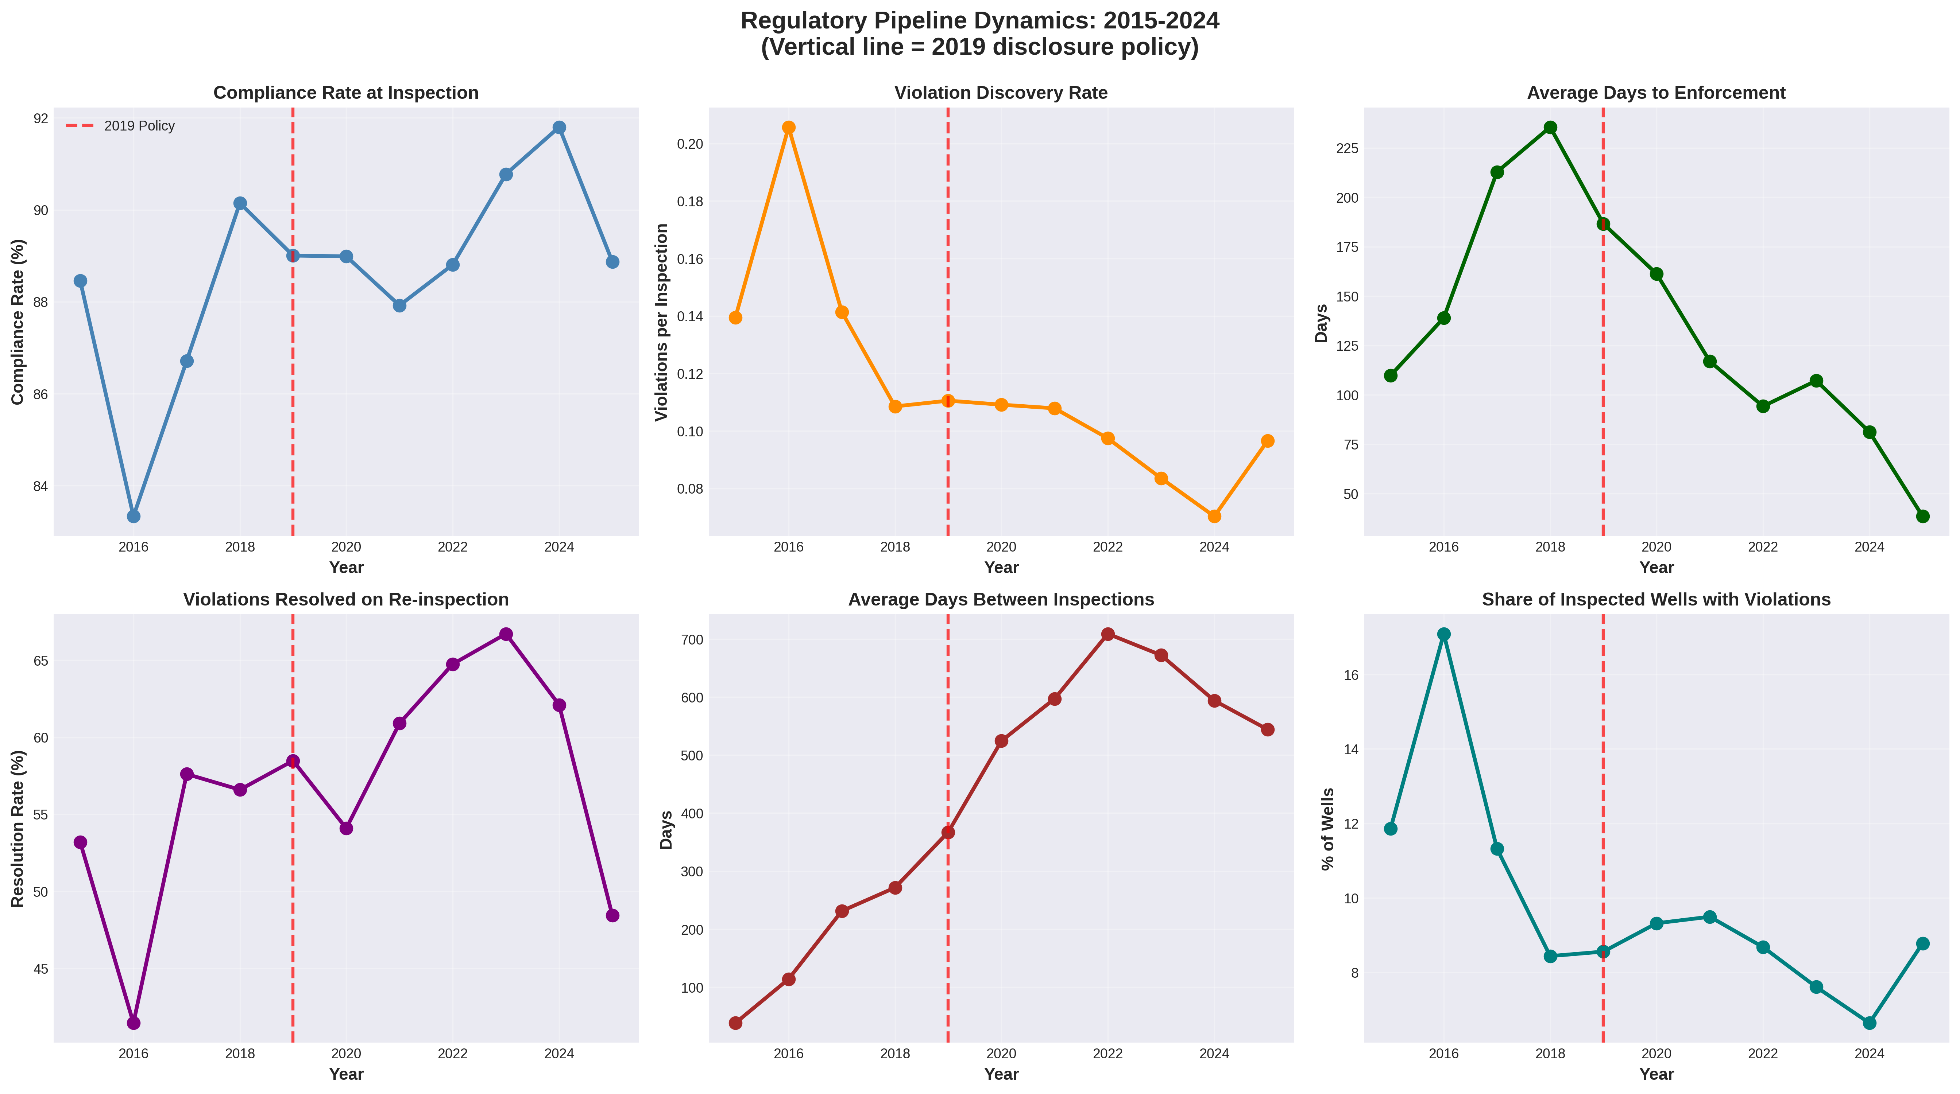 Figure 1. Regulatory pipeline trends, 2015-2025.

H1: Policy-year effects (all districts)
Model 1 (timing outcome):
- post_2019 level shift: 0.1514, p=0.3294.
- post_trend slope shift: -0.3603, p=0.0010.
Interpretation: no statistically significant immediate level break in 2019, but a significant post-policy acceleration trend in enforcement timing.
Table 1. Core policy-year and moderator estimates
Model | Parameter | Coefficient | P-value | Interpretation
Model 1 (All districts, interrupted panel) | post_2019 | 0.1514 | 0.3294 | No immediate level break
Model 1 (All districts, interrupted panel) | post_trend | -0.3603 | 0.0010 | Significant post-policy acceleration trend
Model 3 (District heterogeneity + offshore) | post_2019:offshore_jurisdiction | 0.3819 | <0.001 | Offshore districts relatively slower post-policy timing
Table 1 provides the baseline inferential results for the article’s identification strategy. The table shows that the main all-district effect appears in the post-policy slope term rather than a one-time post-2019 level break, and it also shows that offshore jurisdiction remains a statistically important differential once district heterogeneity is modeled.
Event-study decomposition (relative to 2018) corroborates this dynamic pattern:
- No significant pre-policy years (2015-2017).
- Significant negative deviations in 2022, 2024, and 2025.
Table 2. Event-study coefficients (all districts, reference year = 2018)
Year | Coefficient | P-value | Significant (p<0.05)
2022 | -0.5853 | 0.0333 | Yes
2024 | -0.7829 | 0.0057 | Yes
2025 | -1.4800 | <0.001 | Yes
Table 2 highlights the years where post-policy deviations are most pronounced. Substantively, these estimates indicate that the policy response intensifies over time instead of materializing immediately in 2019.
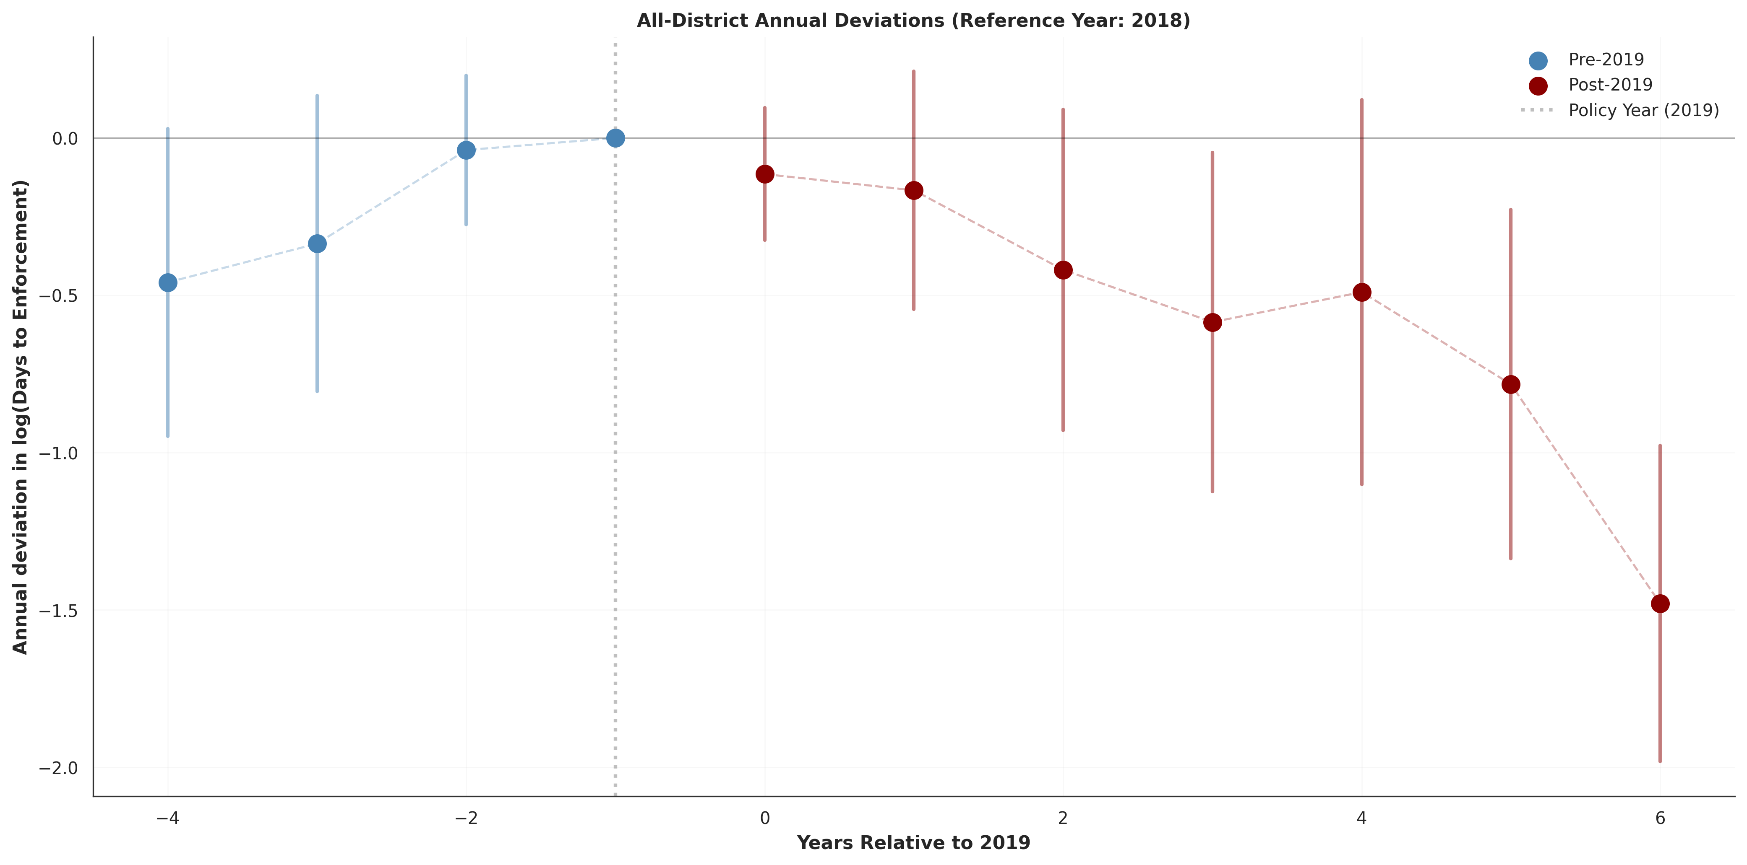 Figure 2. All-district event-study decomposition and offshore differential annual effects.
Figure 2 complements Table 2 by displaying the full time path (including pre-policy years), making the absence of pre-trend significance and the later post-policy acceleration visually transparent.

H2: District heterogeneity
District-level post-policy responses are strongly heterogeneous and jointly significant. Estimated effects range from substantial acceleration (e.g., District 09) to substantial slowdown (e.g., Districts 03 and 04).
From district effect summaries used in mapping:
- Best improvement: District 09 (about -52.6%).
- Largest deterioration: District 04 (about +138.5%).
Figure 3 presents the estimated district-specific effects directly, while Figure 4 maps those effects geographically. Together they demonstrate that heterogeneity is not a minor perturbation around a common effect but a core empirical feature of the policy response.
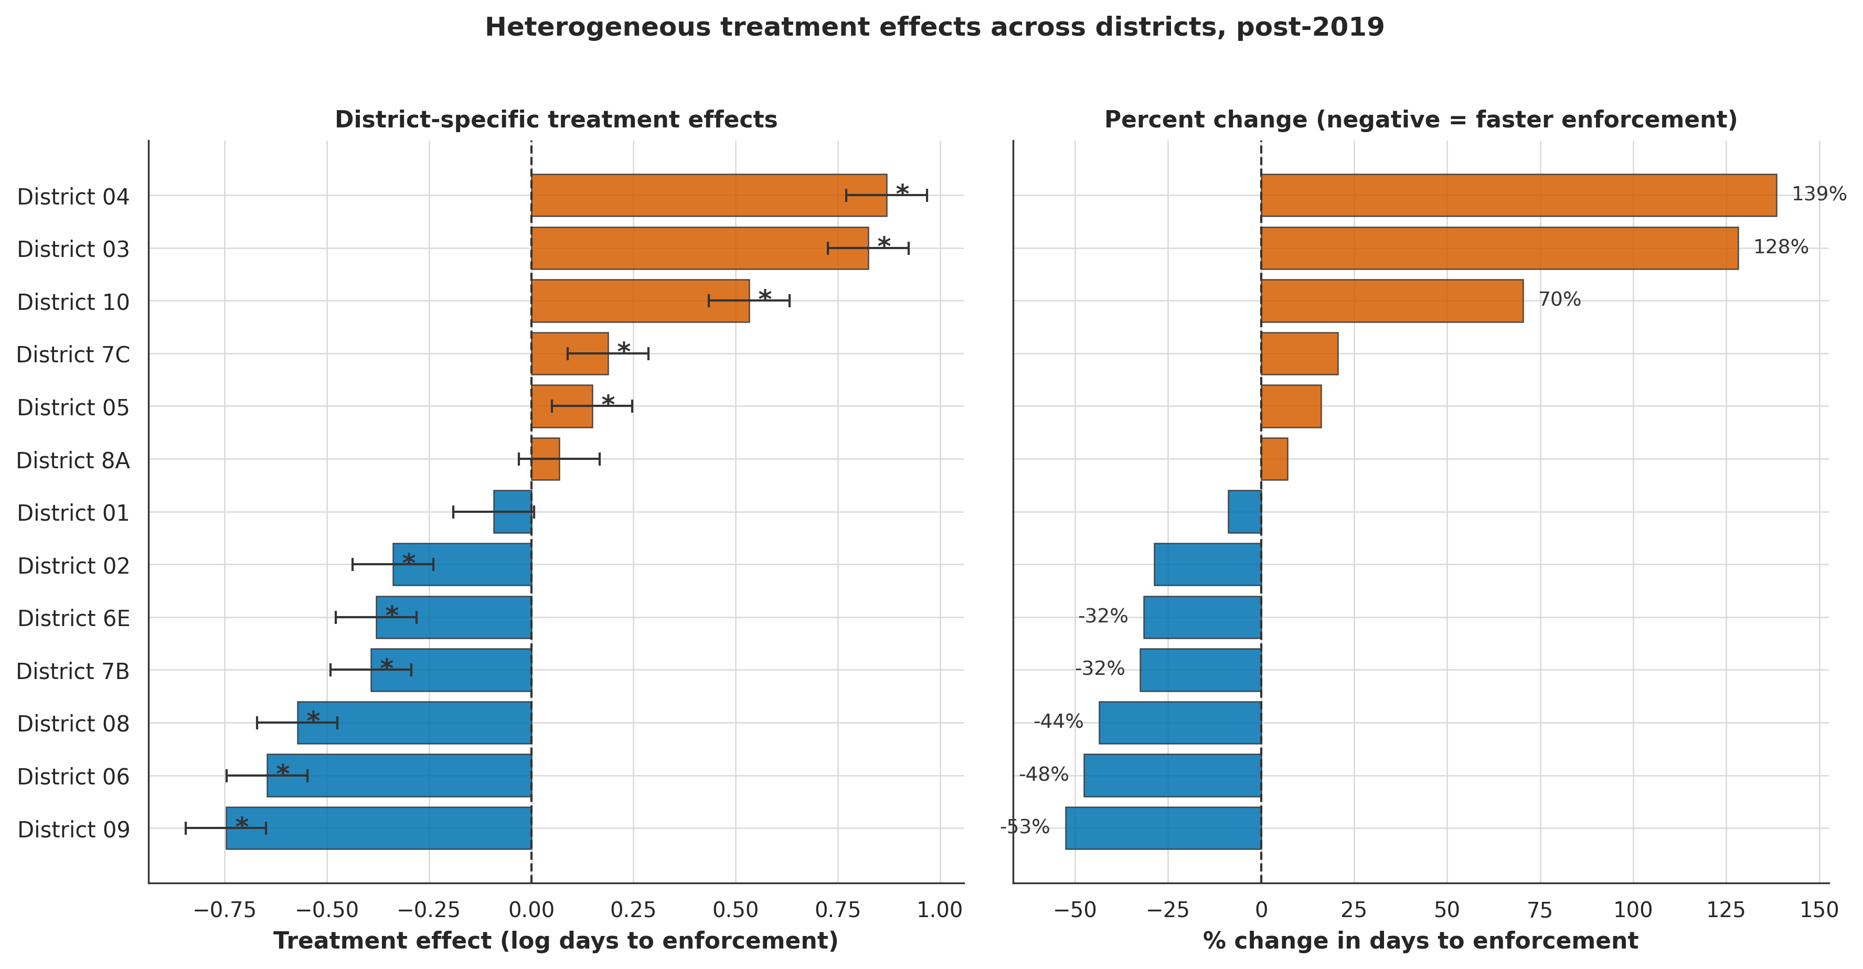 Figure 3. District-specific post-2019 treatment effects.
To show where these effects are concentrated geographically, Figure 4 maps district-level percent changes in enforcement timing.
District Treatment Effects Map Figure 4. Geographic distribution of district treatment effects (percent change in days to enforcement).
The map indicates that large positive and negative effects coexist across regions, reinforcing the need to model district-level discretion explicitly rather than assuming uniform policy implementation.

H5: Offshore moderation
In the conditional heterogeneity model (Model 3):
- post_2019:offshore_jurisdiction = 0.3819, p<0.001.
This indicates that, net of district-specific post effects, offshore-jurisdiction districts experience relatively slower post-policy enforcement timing.

H3: Structural moderators
Main moderator block:
- H3a Capacity: coef -0.0188, p=0.9415.
- H3b Baseline performance: coef -0.0884, p=0.7144.
- H3e Border proximity: coef -0.2768, p=0.3082.
Deep-dive TWFE block:
- H3c EJ context: coef 0.1818, p=0.4866.
- H3f Rurality: coef 0.2213, p=0.4649.
- H3e Border proximity: coef -0.3626, p=0.1669.
- H3d Geology: mixed basin interactions; some terms significant (p<0.001).
Overall, H3 receives limited support except partial geology effects.
Table 3. Structural moderator tests
Hypothesis | Term | Coefficient | P-value | Result
H3a Capacity | post_2019:high_capacity | -0.0188 | 0.9415 | Not supported
H3b Baseline performance | post_2019:low_baseline_compliance | -0.0884 | 0.7144 | Not supported
H3c EJ context | post_2019:high_eji | 0.1818 | 0.4866 | Not supported
H3e Border proximity | post_2019:border_competition | -0.3626 | 0.1669 | Not supported
H3f Rurality | post_2019:high_rural | 0.2213 | 0.4649 | Not supported
H3d Geology | C(primary_basin):post_2019 | Mixed | Mixed | Partial support
Table 3 summarizes why structural accounts are only partially successful in this run: most moderators are imprecisely estimated, while geology shows selective basin-specific effects. Figure 5 and Figure 6 then provide visual context for these moderator patterns.
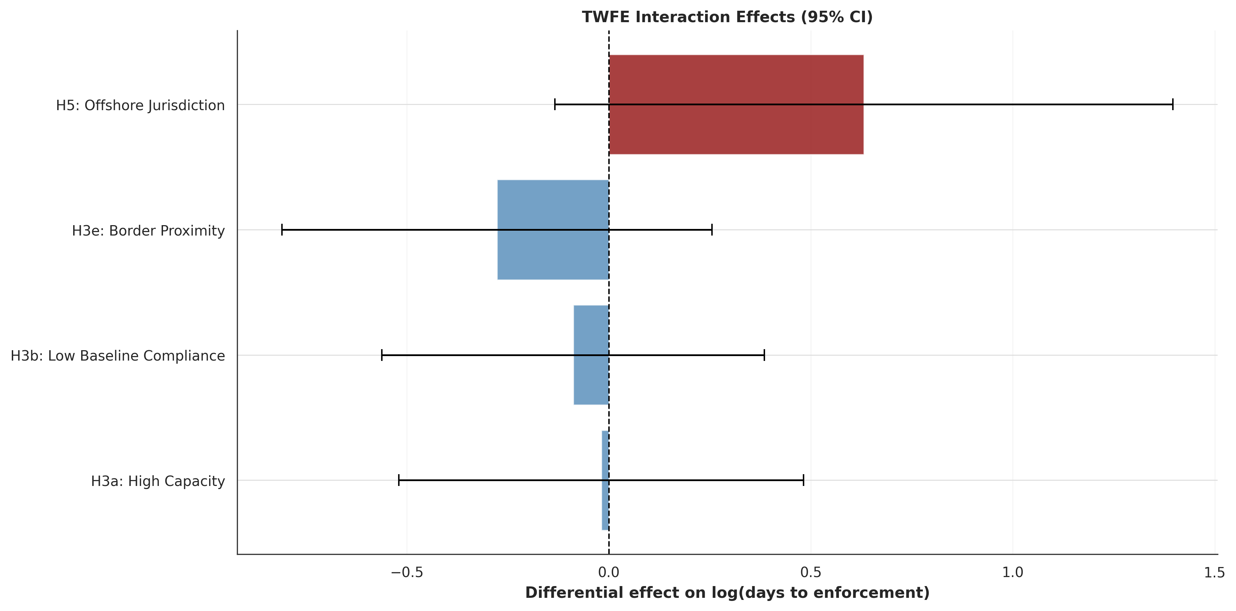 Figure 5. Moderator interaction estimates.
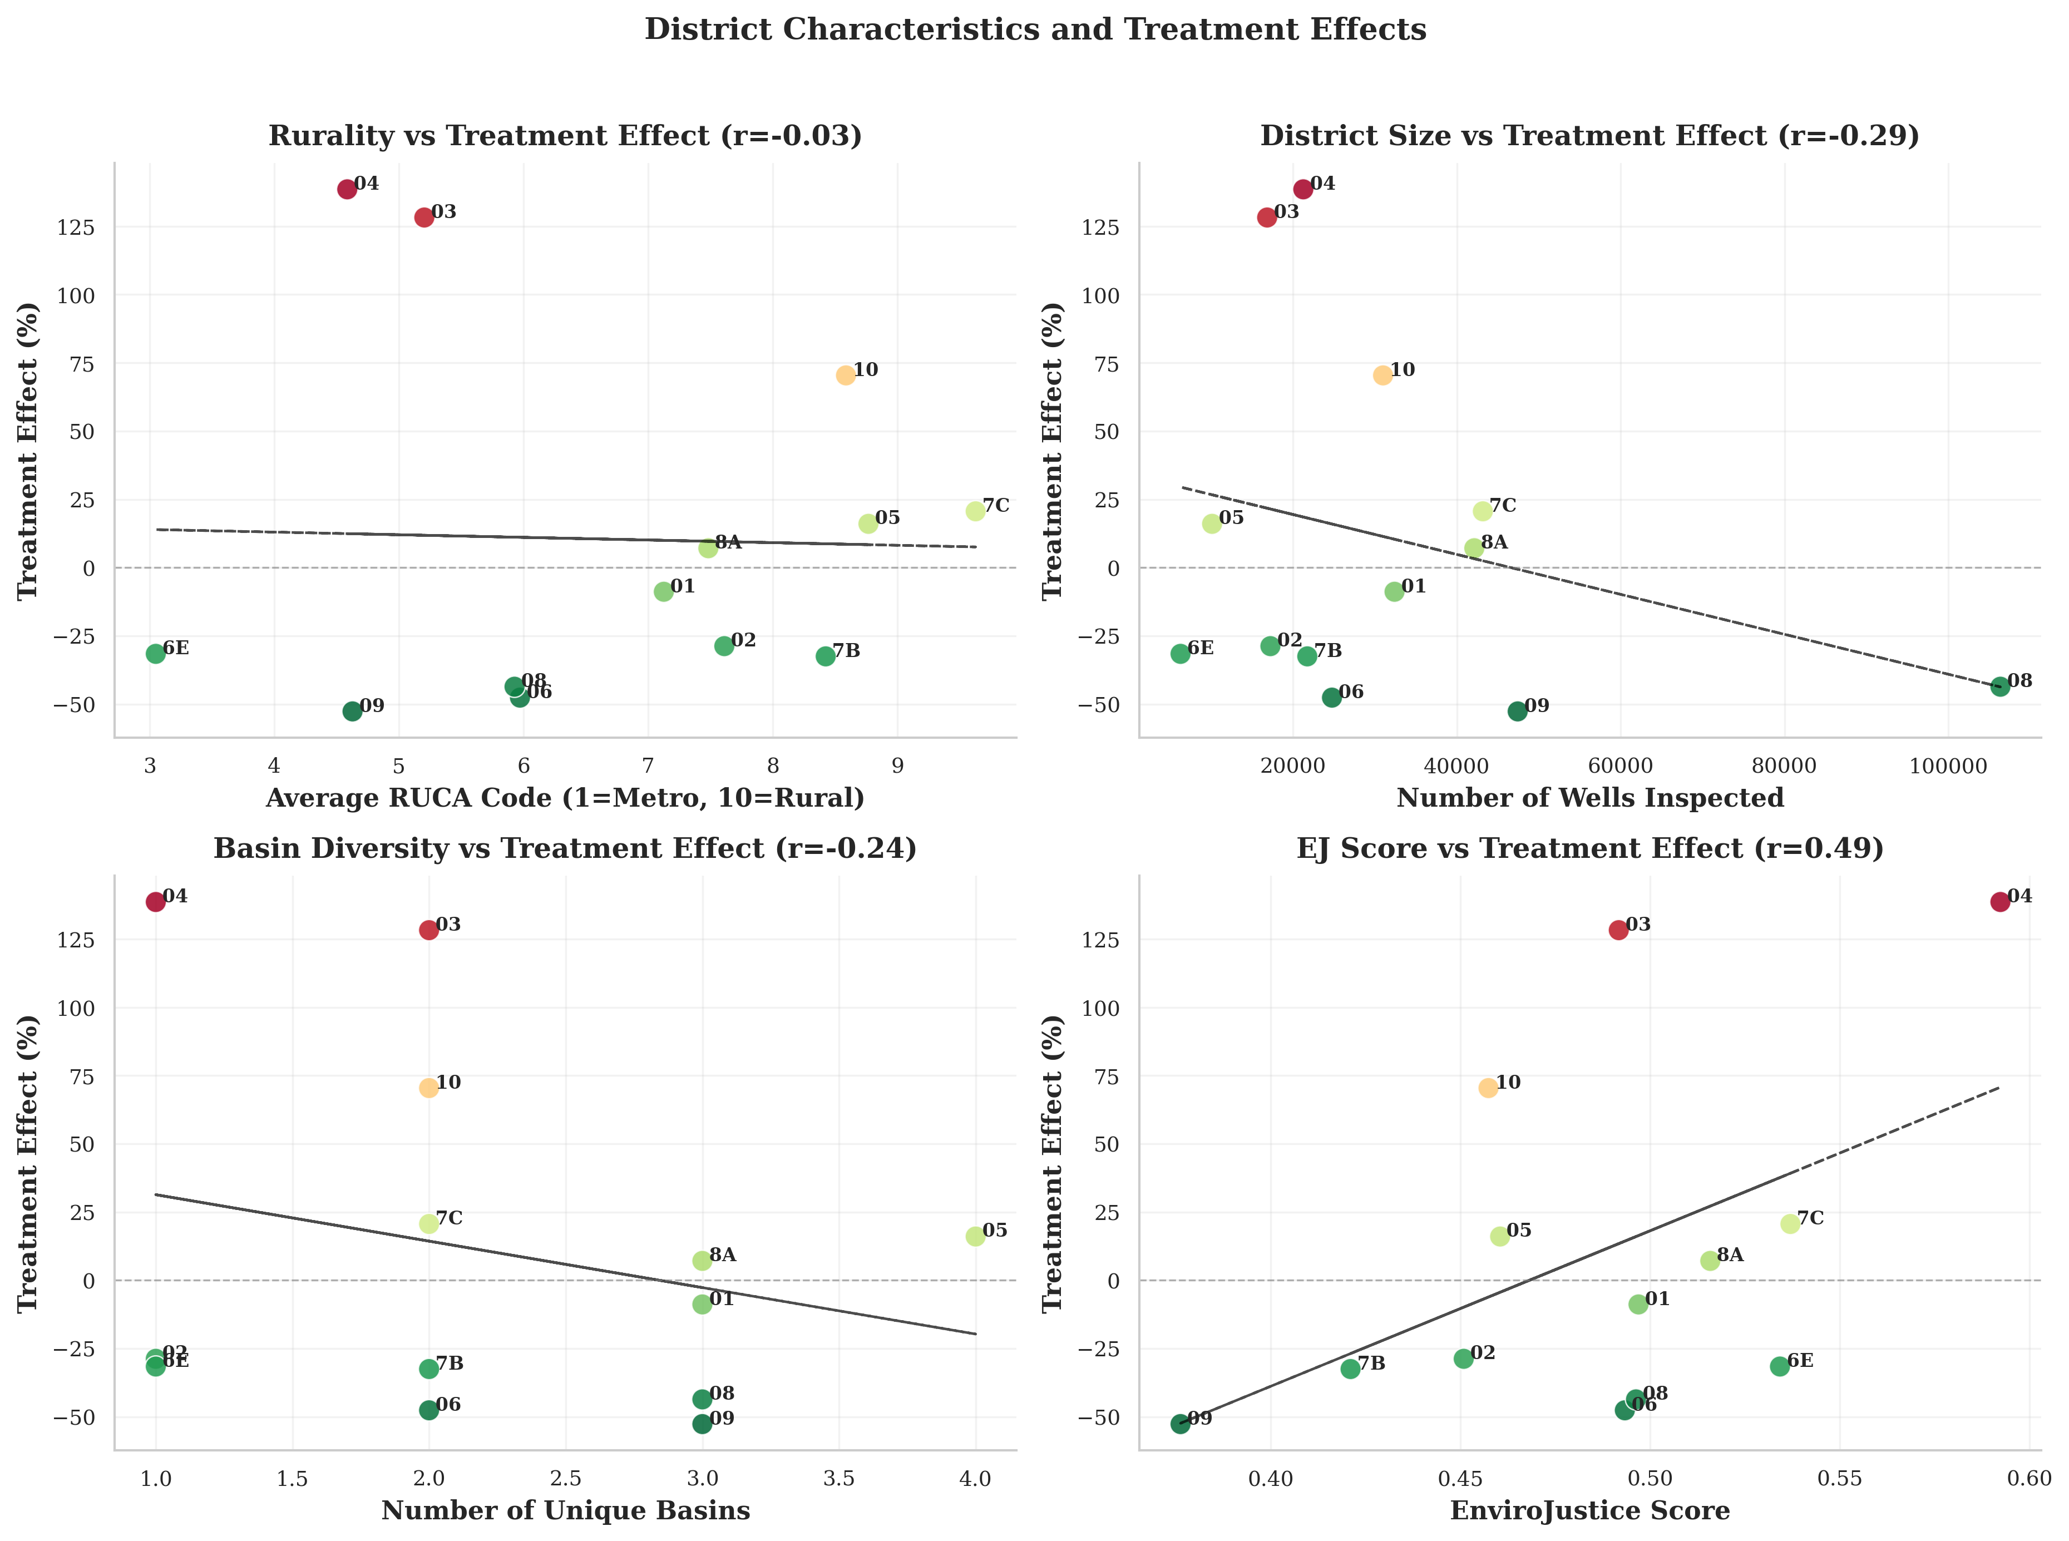 Figure 6. Demographic/geographic correlates of district effects.

H4: Spatial dynamics
Moran’s I on district effects:
- (I = -0.0493), permutation p=0.8550.
No evidence of statistically significant global spatial autocorrelation.
Figure 7 visually corroborates the spatial test by showing no systematic clustering pattern consistent with strong spillovers.
Spatial Spillovers Figure 7. Spatial spillover diagnostics.

Robustness

Placebo policy years (all-district interrupted model)
- 2017 placebo: coef 0.6565, p=0.0020.
- 2021 placebo: coef -0.0245, p=0.9191.

Alternative outcomes (all-district interrupted model)
- Resolution rate: post 4.3721 (p=0.2104), post-trend -2.9371 (p=0.1424).
- Compliance rate: post -0.1311 (p=0.9316), post-trend -0.5562 (p=0.1870).
- Violations/inspection: post -0.0082 (p=0.6690), post-trend 0.0106 (p=0.0600).

Sample restrictions
- Full sample: post 0.1514 (p=0.3294), post-trend -0.3603 (p=0.0010).
- Excluding extreme districts: post-trend remains negative/significant.
- Excluding 2015-2016: post-trend remains negative (weaker significance).
- Excluding 2020-2021: post-trend remains negative/significant.

Specification sensitivity
- Linear interrupted model: post-trend -67.0420 days (p=0.0100).
- Winsorized interrupted model: post-trend -0.3147 (p=0.0016).
Across variants, the post-policy slope result is more stable than the immediate level effect.
Table 4. Robustness summary (interrupted panel framework)
Check | post_2019 (p) | post_trend (p) | Read
Full sample | 0.1514 (0.3294) | -0.3603 (0.0010) | Slope effect robust; level break weak
Exclude extreme districts | 0.1917 (0.1930) | -0.2972 (0.0133) | Slope remains significant
Exclude 2015-2016 | 0.1942 (0.1958) | -0.2313 (0.0950) | Slope negative, marginal
Exclude 2020-2021 | 0.1516 (0.2959) | -0.3599 (0.0016) | Slope remains significant
Linear interrupted | -41.9298 (0.3104) | -67.0420 (0.0100) | Same directional pattern
Winsorized interrupted | 0.2137 (0.1021) | -0.3147 (0.0016) | Slope remains significant
Table 4 consolidates robustness evidence in one place: level-shift estimates are sensitive, but the negative post-policy slope remains comparatively stable across sample restrictions and alternative functional forms.

Discussion
The transparency reform is associated with a gradual statewide acceleration in enforcement timing rather than a single immediate break at implementation. At the same time, district responses diverge sharply, confirming bureaucratic heterogeneity. Offshore jurisdiction explains a meaningful share of that heterogeneity once district-specific post effects are included, while most other structural moderators are weak or inconsistent in this run. Spatial diffusion across neighboring districts is not supported by global autocorrelation tests.
These findings suggest that transparency reforms in decentralized regulatory systems should be evaluated as dynamic, district-conditioned processes, not monolithic statewide shocks.

References:
Anselin, L. (1995). Local Indicators of Spatial Association—LISA. Geographical Analysis, 27(2), 93-115.
Biglan, A., Ary, D., & Wagenaar, A. C. (2000). The Value of Interrupted Time-Series Experiments for Community Intervention Research. Prevention Science, 1(1), 31-49.
de Chaisemartin, C., & D’Haultfœuille, X. (2020). Two-Way Fixed Effects Estimators with Heterogeneous Treatment Effects. American Economic Review, 110(9), 2964-96.
Goodman-Bacon, A. (2021). Difference-in-differences with variation in treatment timing. Journal of Econometrics, 225(2), 254-277.
Linden, A. (2015). Conducting interrupted time-series analysis for single- and multiple-group comparisons. The Stata Journal, 15(2), 480-500.
Sun, L., & Abraham, S. (2021). Estimating dynamic treatment effects in event studies with heterogeneous treatment effects. Journal of Econometrics, 225(2), 175-199.

